Bryan Duong

013104973

CECS 424 Assignment 11

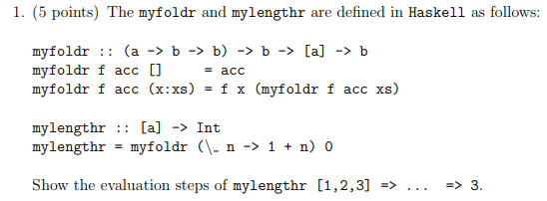

myfoldr (\_ n 🡪 1 + n) 0 [1,2,3]

= (\_ n 🡪 1 + n) 1 (myfoldr (\_ n 🡪 1 + n) 0 [2,3])

= (\_ n 🡪 1 + n) 1 ((\_ n 🡪 1 + n) 2 (myfoldr (\_ n 🡪 1 + n) 0 [3]))

= (\_ n 🡪 1 + n) 1 ((\_ n 🡪 1 + n) 2 (((\_ n 🡪 1 + n) 3 0))

= (\_ n 🡪 1 + n) 1 ((\_ n 🡪 1 + n) 2 1)

= (\_ n 🡪 1 + n) 1 2

= 3

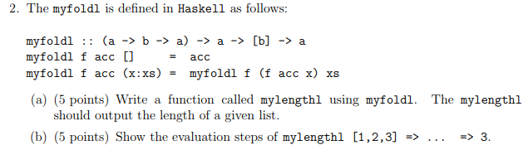

1. mylengthl = myfoldl (\n _ 🡪 n + 1) 0
2. mylengthl [1,2,3]

= myfoldl (\n _ 🡪 n+1) 0 [1,2,3]

= myfoldl (\n _ 🡪 n+1) ((\n _ 🡪 n+1) 0 1) [2, 3]

= myfoldl (\n _ 🡪 n+1) ((\n _ 🡪 n+1) ((\n _ 🡪 n+1) 0 1 ) 2)) [3]

= ((\n _ 🡪 n+1) ((\n _ 🡪 n+1) ((\n _ 🡪 n+1) 0 1 ) 2) 3)

= ((\n _ 🡪 n+1) ((\n _ 🡪 n+1) 1 2) 3)

= ((\n _ 🡪 n+1) 2 3)

= 3

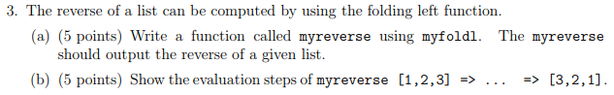

1. myreverse = myfoldl (\n m 🡪 m : n) [ ]
2. myreverse [1,2,3]

= myfoldl (\n m 🡪 m : n) [ ] [1,2,3]

= myfoldl (\n m 🡪 m : n) ((\n m 🡪 m : n) [ ] 1) [2,3]

= myfoldl (\n m 🡪 m : n) ((\n m 🡪 m : n) ((\n m 🡪 m : n) [ ] 1) 2) [3]

= ((\n m 🡪 m : n) ((\n m 🡪 m : n ) ((\n m 🡪 m : n) [ ] 1) 2) 3)

= ((\n m 🡪 m : n) ((\n m 🡪 m : n) [1] 2) 3)

= ((\n m 🡪 m : n) [2,1] 3)

= [3,2,1]